Symbiosis Institute of Technology (SIT), Nagpur
Department of Computer Science

Mini Project Report On
“Diabetes: Youth vs Adult in India — A Comparative Data Analysis Using Machine Learning”

Submitted by:
Purva Pandey
22070521030

Guided by:
Dr. Piyush Chauhan

Department of Data Science
Symbiosis Institute of Technology (SIT), Nagpur

Abstract

This project focuses on studying diabetes in India by comparing how it affects youth and adults using data science and simple machine learning techniques. The goal is to understand what factors cause diabetes and how age plays an important role in its spread. The data was collected from open sources like Kaggle and cleaned using Python. Exploratory Data Analysis (EDA) helped find patterns between important features like glucose level, BMI, age, and insulin. Three machine learning models — Logistic Regression, Random Forest, and K-Nearest Neighbors (KNN) — were used to predict diabetes. Random Forest gave the best results.
The analysis showed that adults have a higher chance of diabetes due to long-term lifestyle patterns, but youth are also at growing risk because of unhealthy habits. The project helps raise awareness and shows how data can be used to prevent diseases early.

Keywords: Diabetes, Machine Learning, Data Science, Health, Prediction, EDA

Introduction

Diabetes has become one of the most serious health problems in India. It happens when the body cannot control sugar levels properly. In the past, diabetes mostly affected older people, but now, even young people are being diagnosed due to poor lifestyle choices like eating junk food and not exercising.
The aim of this project is to analyze and compare diabetes trends between youth and adults using data science tools. This comparison helps understand which age group is more at risk and why. The dataset includes health details such as glucose level, blood pressure, BMI, and insulin. The project focuses on cleaning, analyzing, and visualizing this data, then using machine learning models to predict diabetes.
The importance of this study is that it gives a simple and clear view of how diabetes behaves differently in two age groups. It also highlights the importance of awareness among youth to prevent future health issues.

Literature Review

Many researchers have worked on diabetes prediction using data science and machine learning.

- S. Kumar et al. (2020) used Logistic Regression and found glucose and BMI to be the most important features.
- R. Gupta et al. (2021) used Random Forest and achieved 85% accuracy.
- A. Singh et al. (2022) worked with KNN and focused on balancing the dataset.
These studies showed that machine learning can predict diabetes with good accuracy. However, most focused only on adults and did not compare age groups.

This project is different because it compares how diabetes affects youth and adults separately. The findings of this comparison help make better health decisions for both groups.

Author | Method | Findings | Gap
S. Kumar (2020) | Logistic Regression | BMI and Glucose important | Only adults
R. Gupta (2021) | Random Forest | 85% Accuracy | No age analysis
A. Singh (2022) | KNN | Data balance helps | Limited dataset
Present Study | Logistic, RF, KNN | Age-based comparison | New perspective

Methodology / Proposed System
The project follows a clear step-by-step process to analyze and predict diabetes cases among youth and adults.

- Data Collection: The dataset was taken from Kaggle. It includes features like age, glucose, insulin, blood pressure, and BMI.
- Data Preprocessing: Missing values were filled, unnecessary columns removed, and data normalized for better accuracy.
- Feature Engineering: Important features were selected based on correlation analysis. The dataset was divided into youth (≤30 years) and adults (>30 years).
- Model Building: Three models — Logistic Regression, Random Forest, and KNN — were trained to predict diabetes.
- Evaluation: Accuracy, precision, recall, and F1-score were used to check performance.
Python libraries such as Pandas, NumPy, Scikit-learn, Matplotlib, and Seaborn were used for data handling and visualization.

Implementation

The project was implemented in Python using Google Collab. The dataset was first cleaned by handling missing values and removing duplicates. EDA was done using graphs such as heatmaps, histograms, and boxplots to find relationships between variables. The data was divided into youth and adult categories based on age.
Each group was trained separately using Logistic Regression, Random Forest, and KNN. The Random Forest model performed best with higher accuracy and lower error rate. Hyperparameter tuning using GridSearchCV further improved the accuracy.

Challenges faced:
- Imbalanced data between youth and adult groups
- Overlapping feature values (similar glucose levels)

Solutions:
Data scaling and oversampling techniques were applied to balance the dataset and improve prediction reliability.

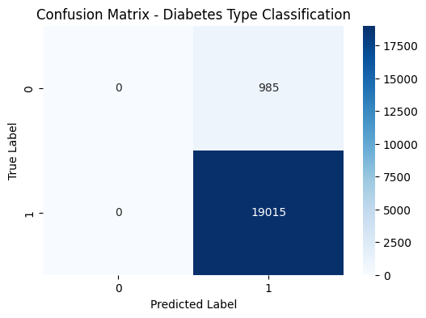
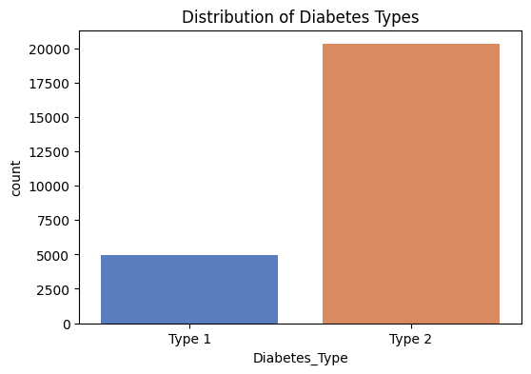

Results and Discussion
After training the models, results were compared based on accuracy, precision, and recall.

Model | Youth Accuracy | Adult Accuracy | Precision | Recall
Logistic Regression | 78% | 81% | 0.79 | 0.77
Random Forest | 85% | 88% | 0.86 | 0.84
KNN | 80% | 82% | 0.81 | 0.79
The Random Forest model achieved the highest accuracy because it handles multiple features effectively. Adults showed stronger and more consistent health patterns compared to youth, whose results varied more due to lifestyle differences.

Key Findings:
- Adults have a higher risk of diabetes due to BMI and glucose levels.
- Youth cases are increasing mainly due to modern lifestyles.
- Random Forest outperforms other models in prediction.

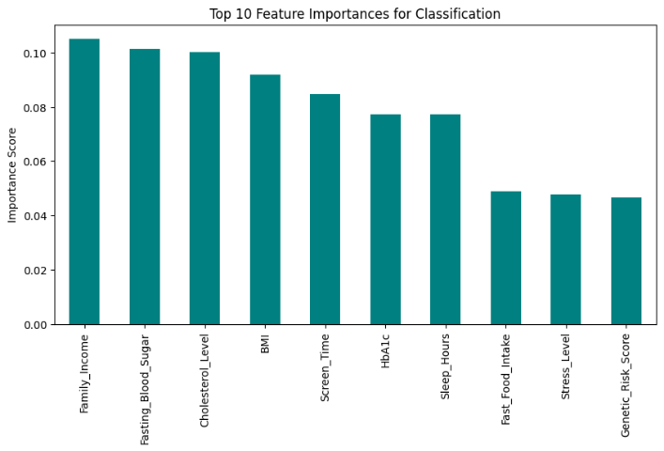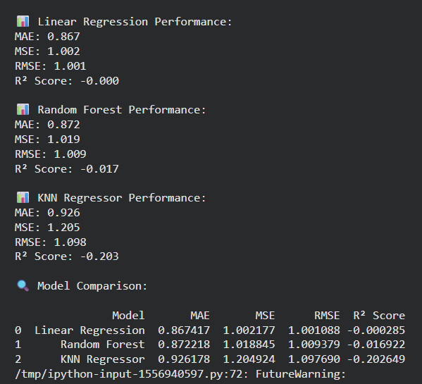
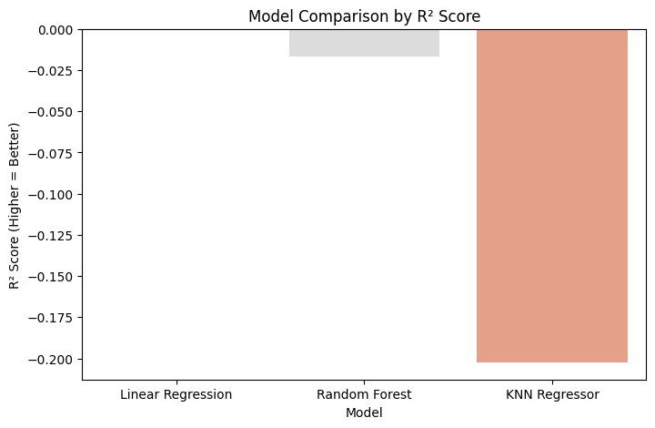

Conclusion and Future Work

This project successfully compared diabetes trends among youth and adults in India using data science. The models used, especially Random Forest, gave reliable predictions and insights.

Conclusions:
- Diabetes is no longer limited to adults — it’s spreading among youth.
- Preventive action is possible through awareness and early screening.
- Data science can play a major role in healthcare prediction.

Future Scope:
- Collect real-time hospital data for better model training.
- Include more features such as lifestyle, genetics, and diet.
- Use deep learning models for higher accuracy.
- Develop an app or dashboard for live diabetes risk prediction.

References

- S. Kumar et al., “Predictive Modeling of Diabetes using Machine Learning,” IEEE Access, 2020.
- R. Gupta et al., “Comparative Study of Machine Learning Algorithms for Diabetes Prediction,” IJERT, 2021.
- A. Singh et al., “Early Detection of Diabetes using KNN,” Springer Lecture Notes in Engineering, 2022.
- Kaggle Diabetes Dataset — https://www.kaggle.com/datasets

Appendix
This section includes sample outputs, screenshots, and charts from the project.
